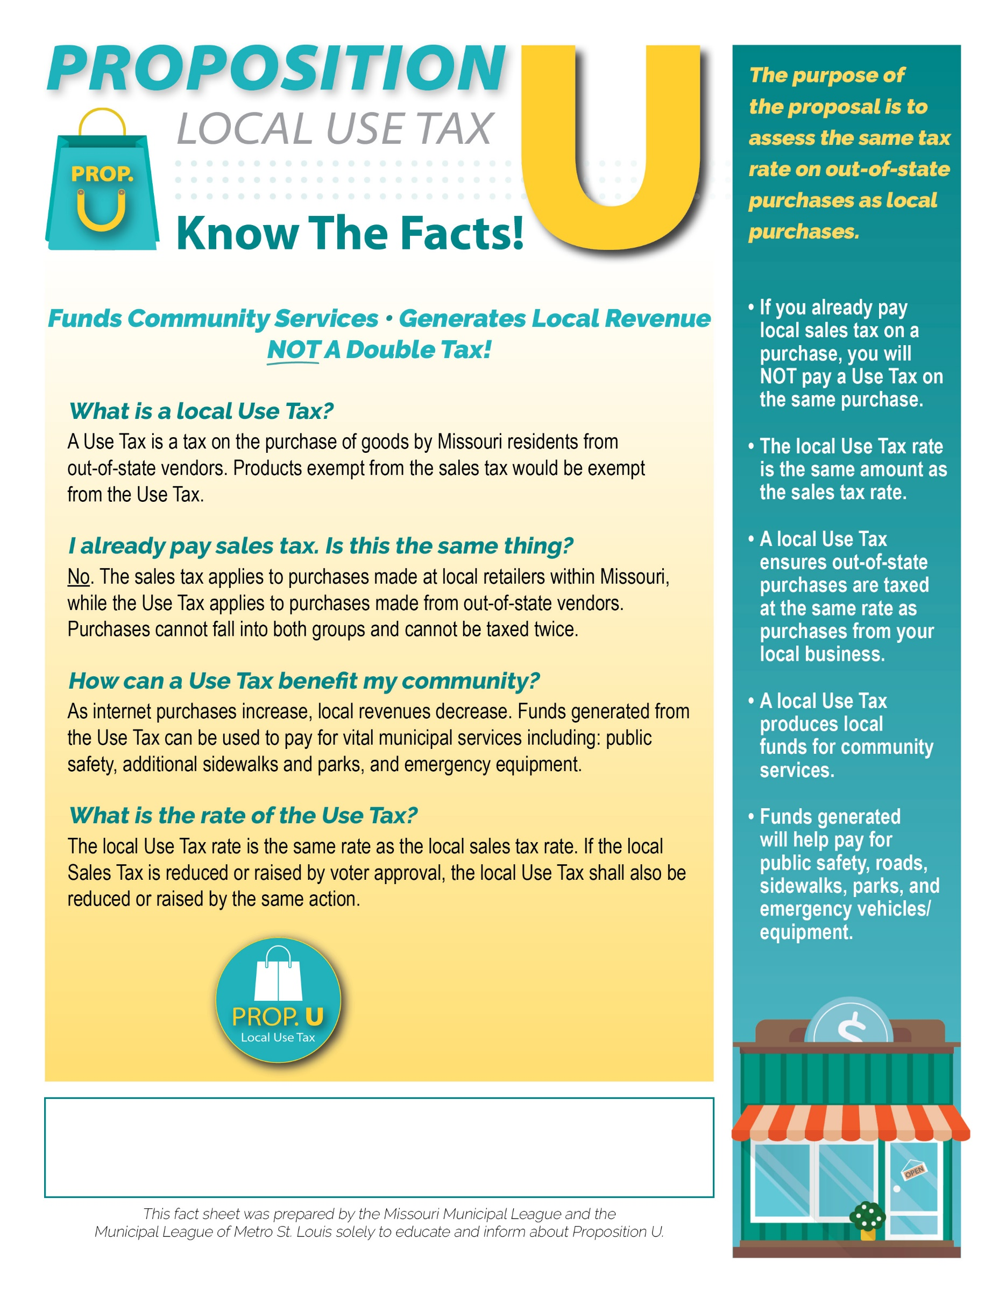
Learn more at: www.
Address
Phone Number | Email

YOUR CITY LOGO HERE
Election Day:

Paid for by

