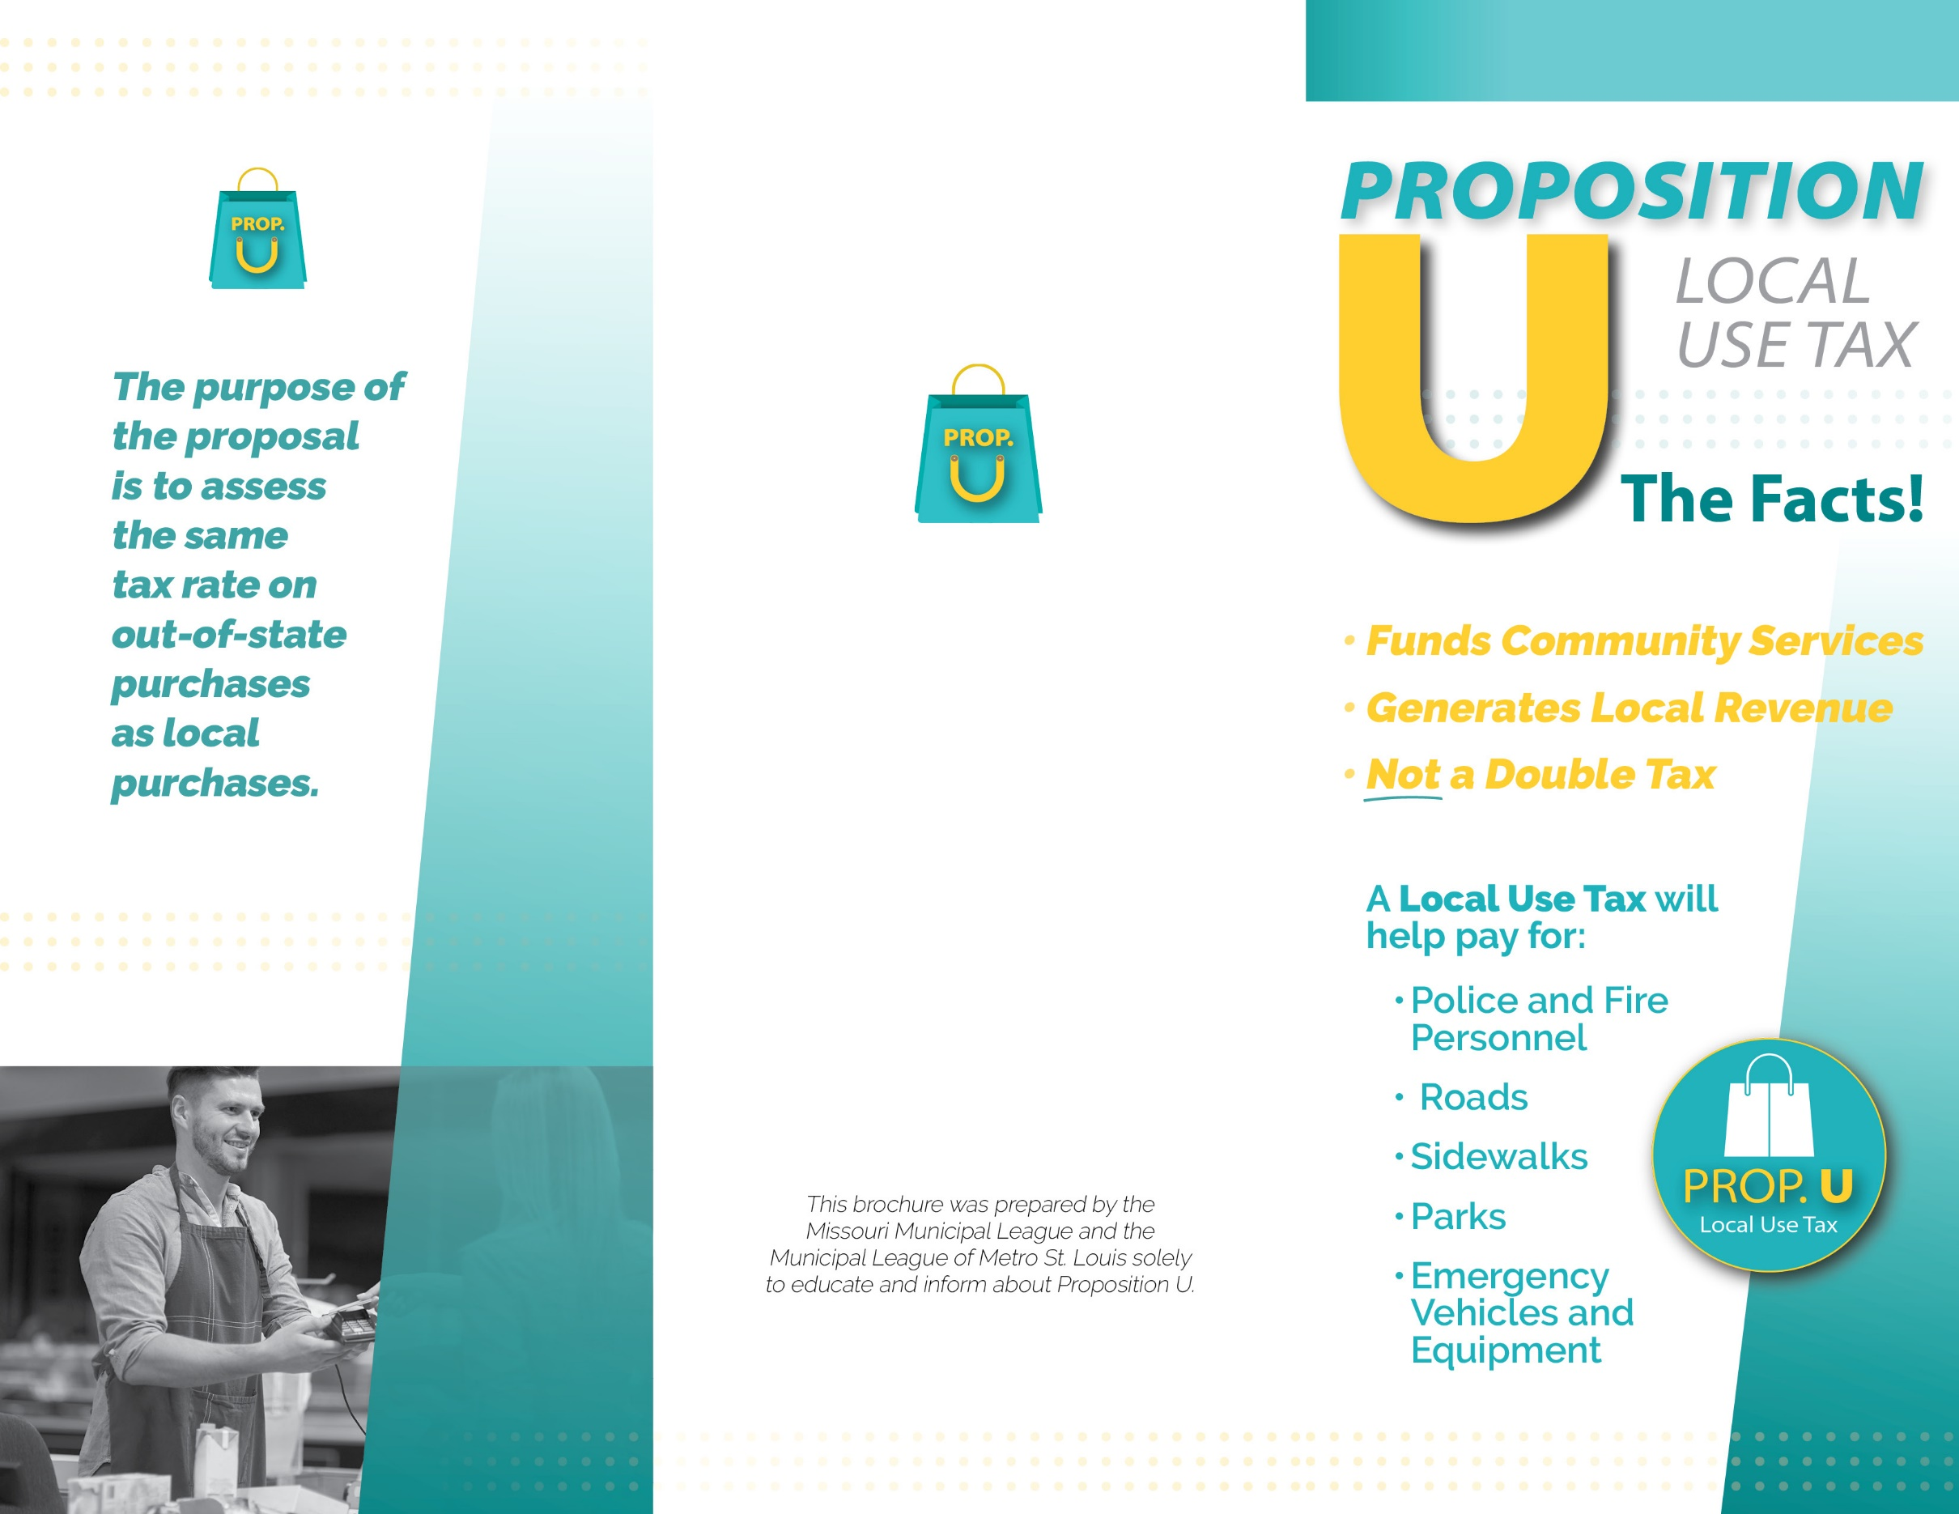
YOUR CITY LOGO HERE
Address
Phone Number | Email

Paid for by
Learn more about Proposition U at: www.
Election Day:
April 5, 2022
